Unity Terrain Creation

Task - 1

Name: Vishnu Vignesh [CH.EN.U4CYS21093]

Screenshots of the created terrain:

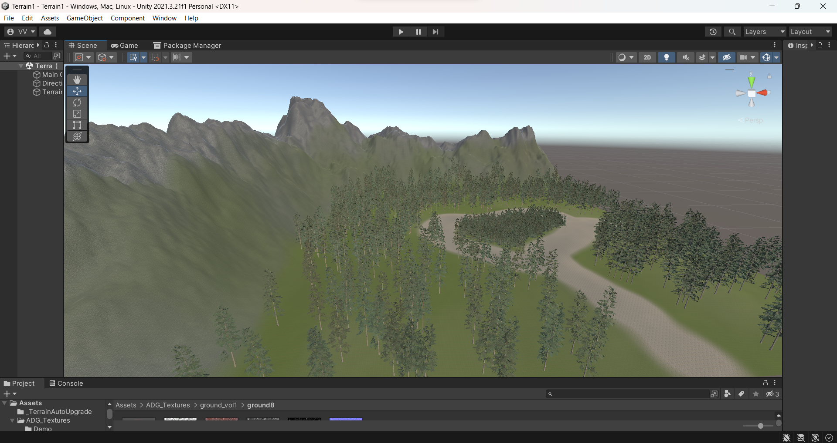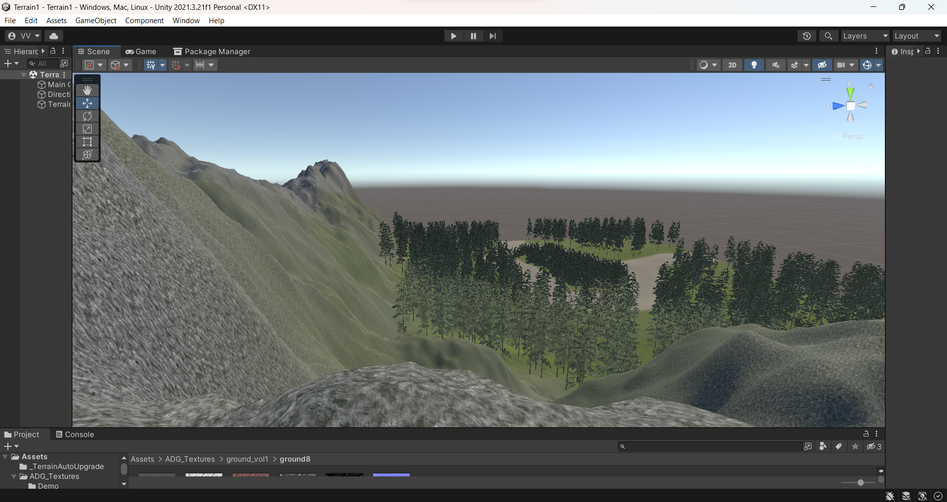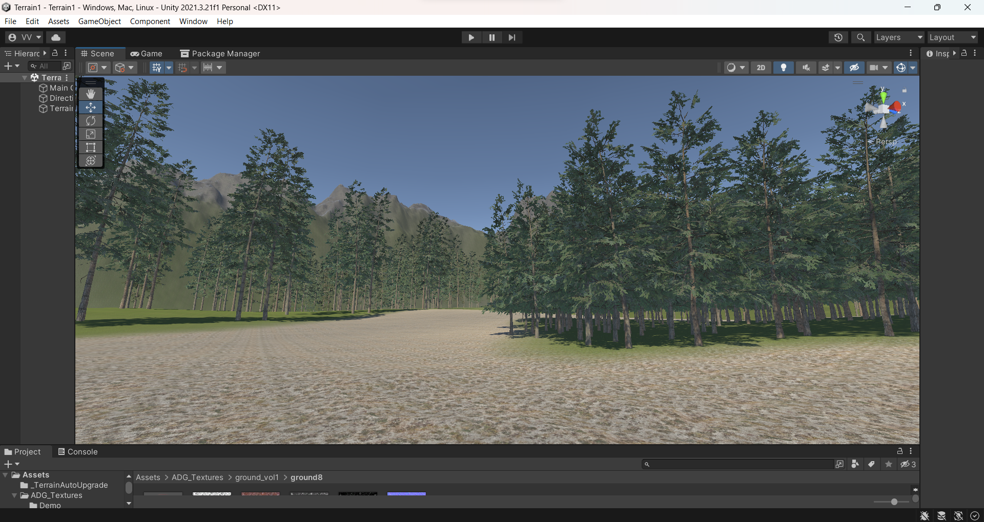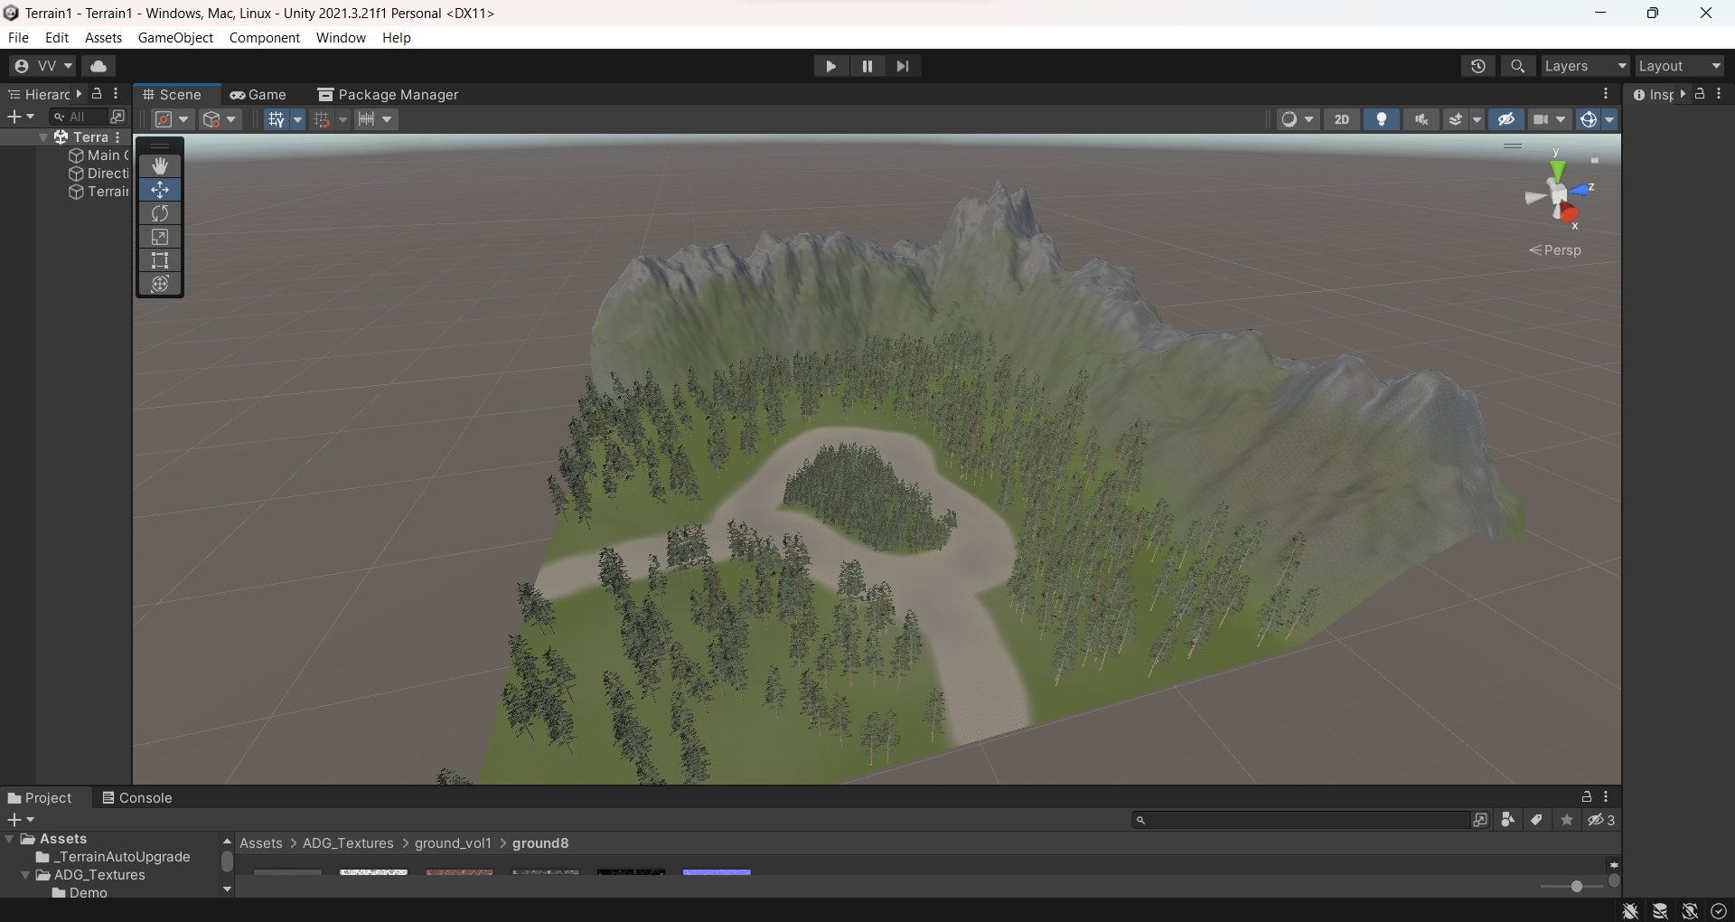

Assets used:

<https://assetstore.unity.com/packages/2d/textures-materials/nature/grass-and-flowers-pack-1-17100>

<https://assetstore.unity.com/packages/3d/vegetation/trees/conifers-botd-142076>

<https://assetstore.unity.com/packages/2d/textures-materials/floors/outdoor-ground-textures-12555>